March 2017

Dear Faithful Partners in Ministry,

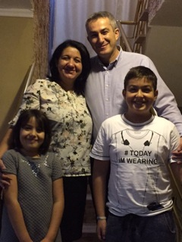**TBBI GRADUATE ANDREI TURCU**

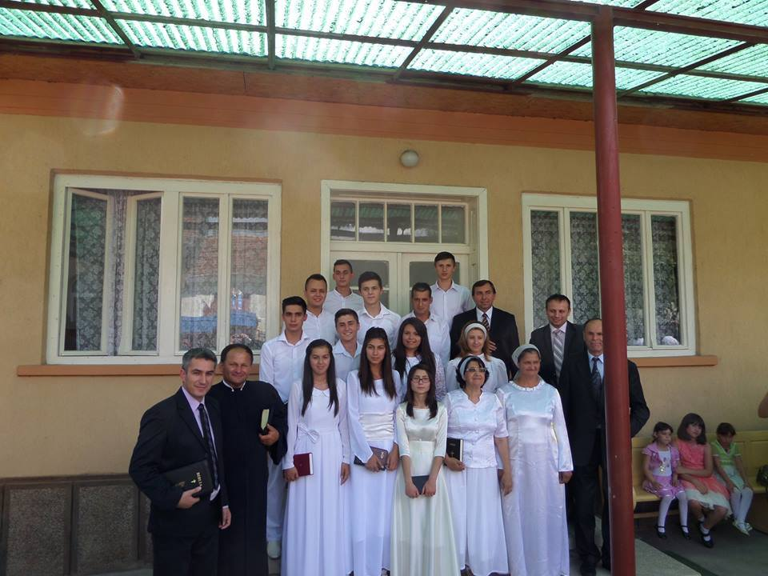“We are in the beginning of a **new year with a desire for God to use us in 2017 to honor and glorify Him**! We desire a **greater relationship with God as a family**; in our relationship with brothers and sisters from the church, which I serve; and **relationships with others**. For this year, as a family we proposed to **discover God much more through the Scripture** and His care for us in every moment **through blessings and trials**. I proposed to help my brothers and sisters from church as a servant to **walk close to God and show His love;** to be **united in the love of Christ** and to teach them to carry forward the **Gospel of God to the unsaved people**. **We are preparing for a week of evangelism**. We pray people will be **touched by the Word of God** in this time of evangelism and we continue to visit people in their homes. We gather every **Tuesday for prayer time**, every **Thursday for youth time**. On **Sunday morning and evening our worship** services together as a church family. We are looking forward to spending time together **this summer for the work God is going to do through Vacation Bible School and other ministries.**

**We want to ask you to support us in prayer for**:

- For our boy Emanuel Andrei, that God heals him

- For a place in Strehaia town to start an evangelism work

- We are in need a house for us.

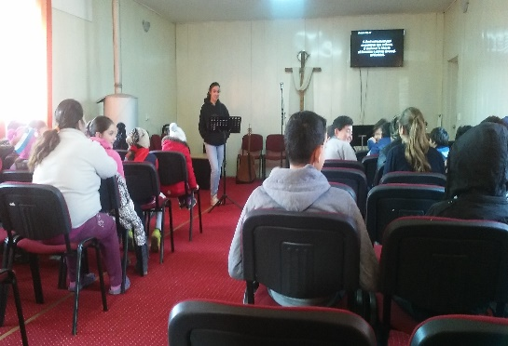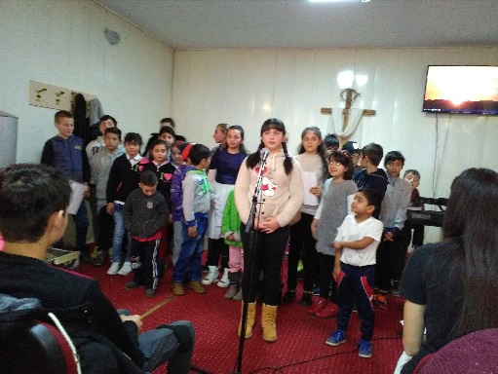God reward you for all your support in the name of Jesus.

Be blessed by God.” Jude 24-25.

Sincerely yours in Christ,

Andrei, Luminita, Emanuel

and Cristina Turcu

**DON KYER MEMORIAL BUILDING**

**PLEASE CONTINUE TO PRAY:**

* We still do not have permission to move forward with the remodel. The Structural Engineer needs to give us the go ahead to continue the remodel with the **‘new revised plans’**!
* Continue to pray for the **funds to complete the building**
* 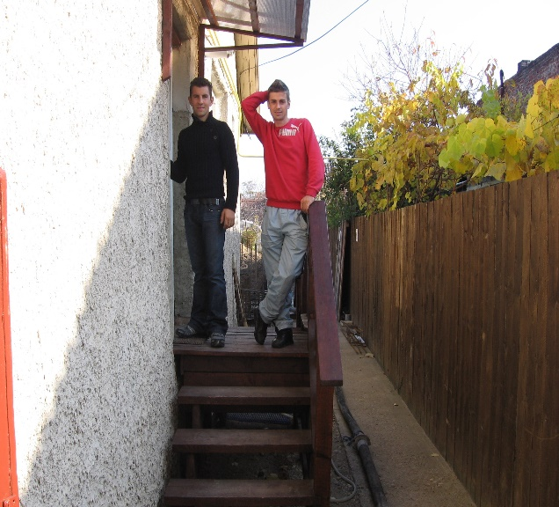Continue to pray for the **safety of the construction workers**

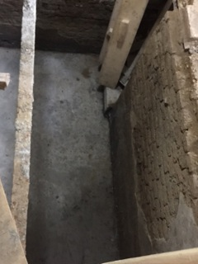

823

[**"We are all faced with a series of great opportunities brilliantly disguised as impossible situations."**](http://www.great-quotes.com/quote/36190) *—* [*Charles Swindoll*](http://www.great-quotes.com/quotes/author/Charles/Swindoll)

|  |
| --- |
| **We are now set up for the Online Giving –** Please contact us and we will send you the information needed to sign up. 423-243-7961 or 423-715-2784 or visit <http://frontlinefellowship.org> |

