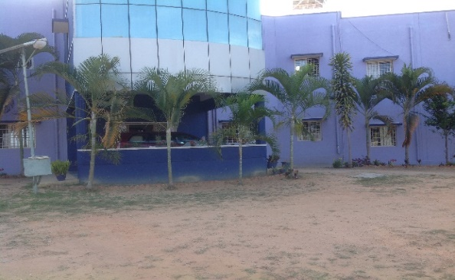
November 2016

Dear Faithful Partners in Ministry,

MARNATHA BAPTIST BIBLE COLLEGE & SEMINARY
URGENT PRAYER REQUEST!
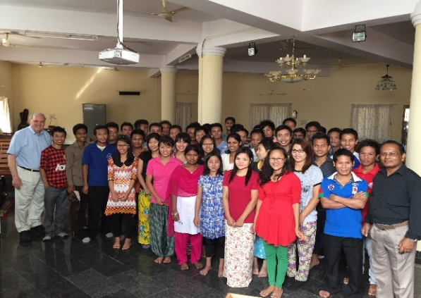
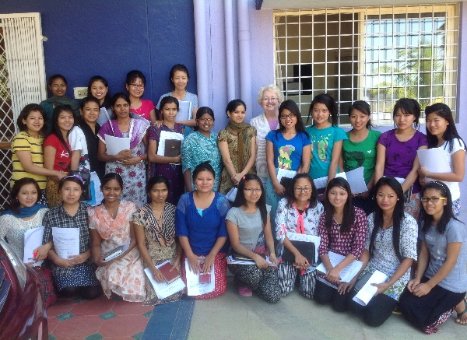
Greetings from Maranatha Baptist Bible College and Seminary, Bangalore, India. Thank you for your faithful Prayers and support. It means so much to this work. We are already two months into the first semester of the academic year. There is much to praise God and also to pray for.
This week we heard that a small part of the College land has a title dispute against it. This title dispute is being raised by the sons of the man who had sold his piece of land, (adjacent to the other three pieces which together made the two acres that we bought in2004) over 30 years ago to another man. The son’s claim that the sale by their late father 30 years ago was not valid. That person who bought it sold it multiple times and finally to our College in 2004. We have all the original Title deeds and other documents from the two previous owners and rightfully registered it to Maranatha Theological and Educational Trust. Now they have accused all the four successive buyers. Their accusation was that the original transaction 30 years was not valid and now we have to go through this painful court process. I believe this is another attack of the Devil on the ministry but we believe the LORD will give us the Victory. I need the spiritual strength and time so I am requesting for you to earnestly pray with us as we go through this process. Gospel Ministry is tough in this dark land and all the people that we deal with do not have sympathy for Christian work or for truth and justice. Our struggle is really with forces of the evil one but the LORD has brought us many victories.
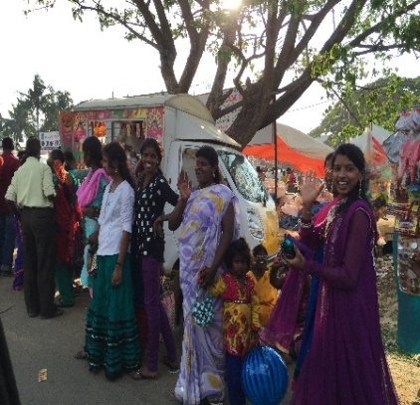
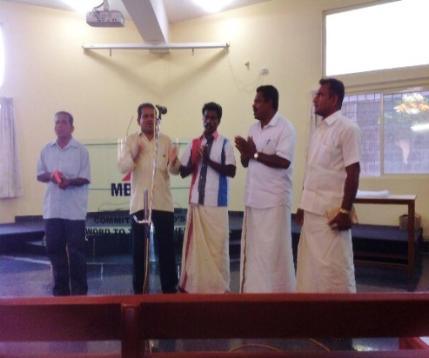
On a better note, we are looking forward to the coming of Frontline Fellowship Pastors and Leaders to teach in the second Semester. Our students, over hundred, in the dorms and Faculty are excited about their coming. We have started praying for the Graduation coming up in March when Pastor Mike Allen and Lisa are expected. During the first week of November we will have a Pastors’ Conference. Also pray for our Orphanage children and 19 pastors of Reaching Ministry, mostly our graduates. We Love you and pray for you every day. Greatly appreciate if you could drop us a word. pjmathai@yahoo.com

Support needed: To support one Indian student costs $75 a month. Would you prayerfully consider this need?

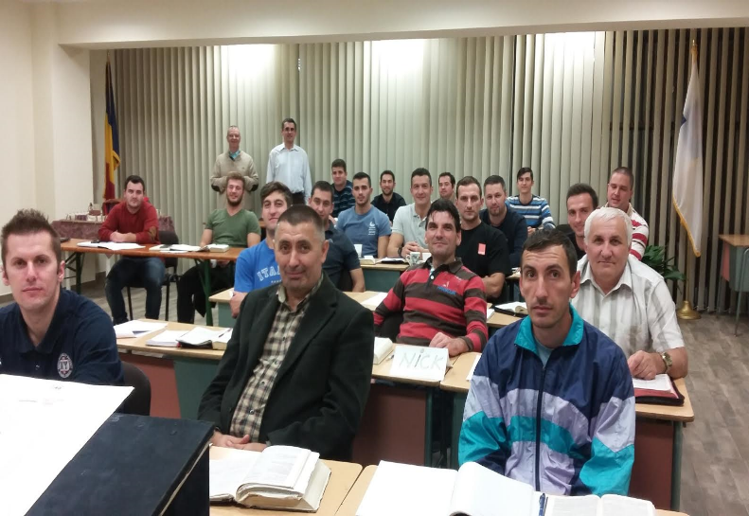
2016 TBBI STUDENTS
Our twenty third year has begun at our school in Timisoara. The Lord has blessed us with a good class of men who desire to reach Romania and beyond for Christ.

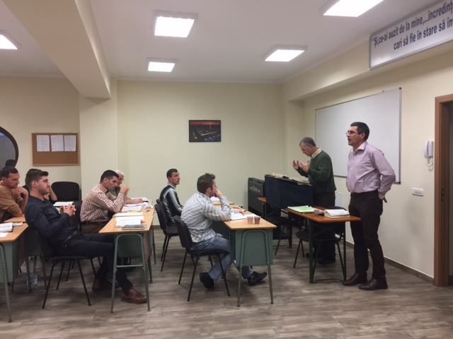

Our Director Mike Allen just returned where he had the opportunity to teach in our Bible Institute. Eighteen students attended the sessions. He taught the book of Ephesians and was blessed by the desire of the students to learn the Word of God. Mike and Lisa ministered with several of our graduates in there village churches.
Dani Velcota serves in a church in Vox Domini Baptist Church. Andrei Turcu and Gabriel and Constantine Cismaru have churches in the Oltenia region of Romania where we will hold Vacation Bible School next summer. Two of our students who are currently in their second year of study are pastoring in the mountains in Sannicolau Mare.
The building was actually given to the congregation by the Catholic Church. How amazing is our God!!

We are praying for six more partners at $150 a month to support our students. Would you prayerfully consider helping with this vital need to keep our school in the black.

ALERT: In order for us to send more money to our missionaries we would like to send your gift receipts and Partner Letter by email. Please let us know if you would be willing receive your receipts in this way. You can email or make a note on your next gift.

“Faith never knows where it is being led, but it loves and knows the One who is leading.” Oswald Chambers

We are now set up for the Online Giving – Go to our web site: www.frontlinefellowship.org .
423-243-7961 or 423-715-2784

Bill and Judy Fortner

